“The Greek government needs time not money.”

What we are saying to the Eurogroup. However, looking the non-papers from the Eurogroup meetings,, except from time we are asking an increase in the limit of the commercial paper funding from ECB a return of the profits of the bonds that ECB bought in the peak of the crisis and the ability to use the 11 billion from the EFSF that normally should return to the creditors.

In the same document, Mr. Varoufakis, outlined the plan of the Greek government. I came to look closely to the debt sustainability explanation and thought to look closer the analysis in order to stay in shape.

The argument that the MOF gives is that with 4% GDP growth, a primary surplus maintained at 1.5% that goes to debt repayment and 5% discount rate the NPV Debt-to-GDP ratio would be reach 127% in 2020. (Chart1). His argument is that under the IMF expectation of 4.5% primary surplus that fully goes to debt repayment the debt is fully repaid in 2050, which is not the purpose of the sovereign debt (in his own words this is not the definition of sustainability”).

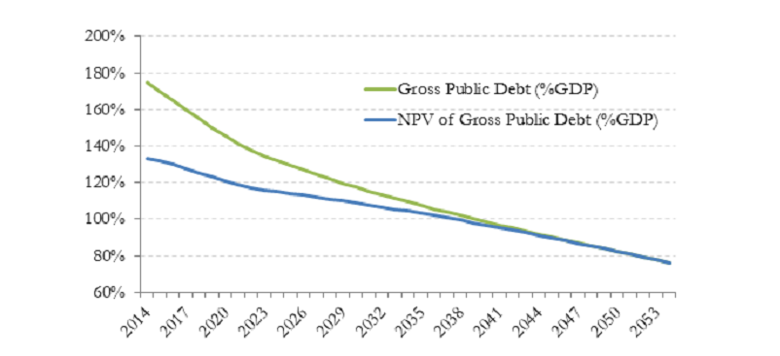

Photo 1

Remember that he goes to this reports goes to FM of EU countries that have heard a million times promises about reforms that were not delivered. I would do just look the macro assumptions for discussion purposes to see if there is something there.

So let’s look the numbers used by the Greek Gov, because I think that there is some optimism in there.

**Growth 4%**

They used a 4% average growth. The IMF has taken an average 4,4% so there they are ok.

**NPV dominated debt**

Why the hell he is using NPV dominated debt for the ratio calculation, when the IMF report they haven’t used the term NPV. Without having an experience in sovereign debt, I find this reasonable as I would find intimidating to calculate the average discount rate for the next 20 years for a financial unstable country, like Greece. But then they take the ratios using the debt NPV and company with nominal debt ratio calculated from IMF. I guess they havnet heard the saying “compare apples with apples”.

**Discount rate 5%**

Ok they discounted the debt. Why they are using a 5% discount rate? Is it because it’s a round number? Can I assume that this an effective interest rate on the debt? However the IMF has an average interest rate around 3.3% (see chart 3). Have they taken a refinance assumption? If they did, have they considered the impact on the interest payment and the primary surplus. Nobody knows (neither the other finance ministers).